***ELL205 PROJECT***

***SIGNALS AND SYSTEM***

(BY- **Tanmay Jhalani- 2021EE30389**

**Ram Gopal Chaudhari- 2021EE10671)**

**OBJECTIVE:** Detection of periodic signal in the presence of noise by correlation and its extraction using filtering.

**THEORY:**

* Detection of the periodic signals masked by noise signals is of great importance in signal processing. It is mainly used in the detection of radar and sonar signals, the detection of periodic components in brain signals, in the detection of periodic components in sea wave analysis and in many other areas of geophysics etc.
* Let the input signal be y(t) which contains a period signal x(t) and noise n(t).

y(t)=x(t)+n(t) and is periodic.

* The noise signals are uncorrelated with any of the periodic signals and therefore the cross correlation function of the signals x(t) and n(t)=0.

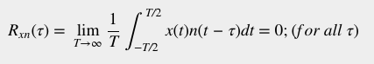

* We can detect the periodic signal using autocorrelation and cross-correlation.

1. **CROSS CORRELATION:**

In this method we should be knowing the frequency of the signal x(t) beforehand (not helpful).

So let us consider a signal z(t) which has same frequency as that of x(t).

Then the cross correlation between y(t) and z(t) gives:

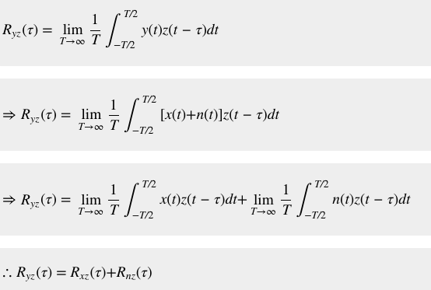

Since Rnz=0 (no correlation between noise and periodic signal) -> Ryz=Rxz.

Here, the signals x(t)x(t) and z(t)z(t) are signals of the same frequency. Therefore, the correlation function Rxz is also a periodic function of the same frequency. Hence, if the cross-correlation of the mixed signal y(t) with z(t) results a periodic signal, then the signal y(t) must contain a periodic component of the same frequency as that of the signal z(t). In this way, we can detect a periodic signal in the presence of noise using cross-correlation.

1. **AUTO CORRELATION:**

This is a more useful approach as here we don’t need to know the frequency of periodic function beforehand.

When we correlate y(t) with y(t) then->

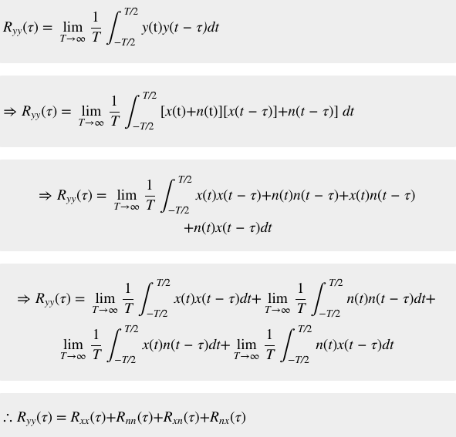

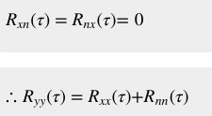

Correlation means the similarity between two signals along with time shifting.

So as (τ) increases Rnn becomes negligible as n(t) is aperiodic and if we see the correlation between n(t) and n(t- τ) then that is negligible.

So Ryy=Rxx

So this means that if we autocorrelate a signal then the output we obtain has the same frequency as that of the periodic signal (x(t)).

* So once we know the frequency then we can extract the periodic signal in the presence of noise using filtering that is equivalent to cross correlation.

CROSS CORRELATION

x(t) Rxy

y(t)

* If we convert everything to Fourier transform then->

X(w)<-> x(t), Y(W)<->y(t),

Rxy<->X(W)Y(-W)

X(w) Rxy

FILTERING

Y(-w)

1. **Extraction using Filtering**

With the help of autocorrelation, we know the frequency of the periodic signal x(t). And we know that Fourier transform of a period signal is an impulse train. So our L(-w) is a unit impulse at frequencies 0, +-wo,+-2wo,+-3wo….L(w) is the Fourier transform of a periodic function having same period as that of x(t). Y(w) is the Fourier transform of the signal containing noise.

L(-w) is the transfer function which attenuates all the frequencies except at w=0, +- w0,+-2wo….

The output thus obtained consists of signal with frequency components w=0,+-wo,+-2wo….

And when we take the fourier inverse of the output then it gives us the correlation Rxy which gives us idea about the periodic signal.

**Code:**

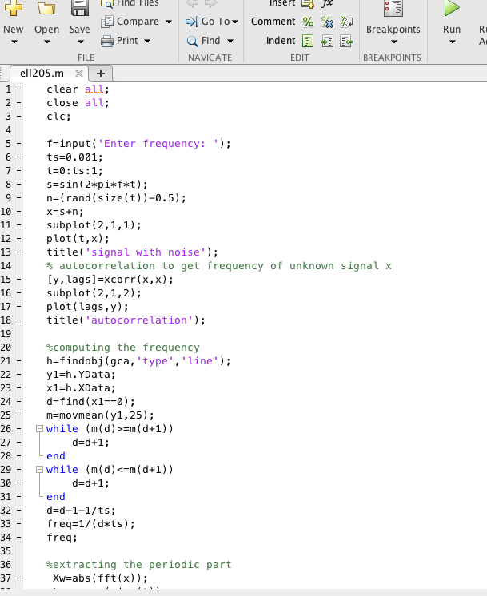

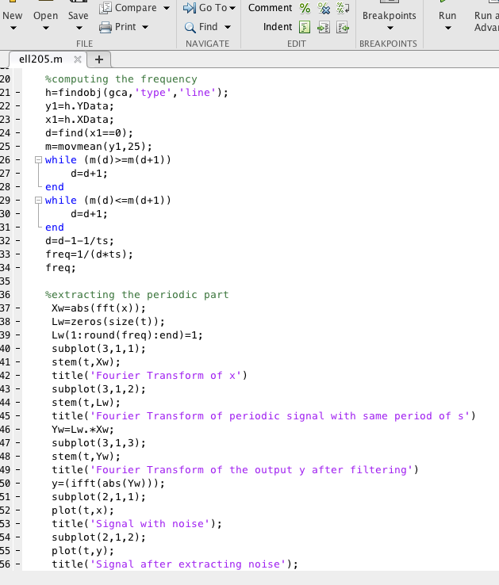

**Example:**

* We took a signal x(t) which contains a periodic signal s(t) of frequency f and a random noise signal.
* When we did its auto correlation we found

the following plots->

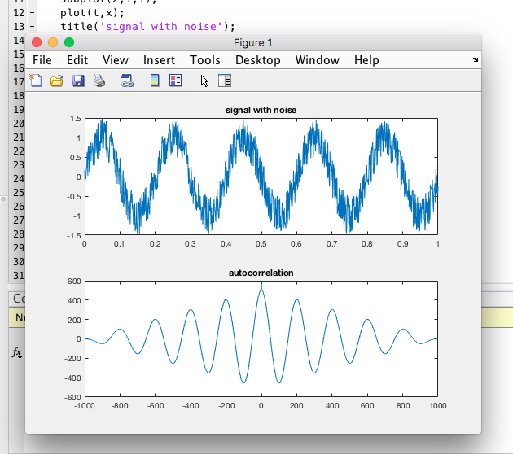

* Now we can compute the frequency of the noisy signal using the autocorrelation plot if we know the distance between two maximas…as it corresponds to one cycle (as after one complete cycle of lag the graphs will again overlap with each other and we would obtain maximum correlation).
* We wrote a code to get this distance and thus the frequency of the unknown periodic signal.
* After this we calculated the fourier transforms and the input and thus got the resulting output->

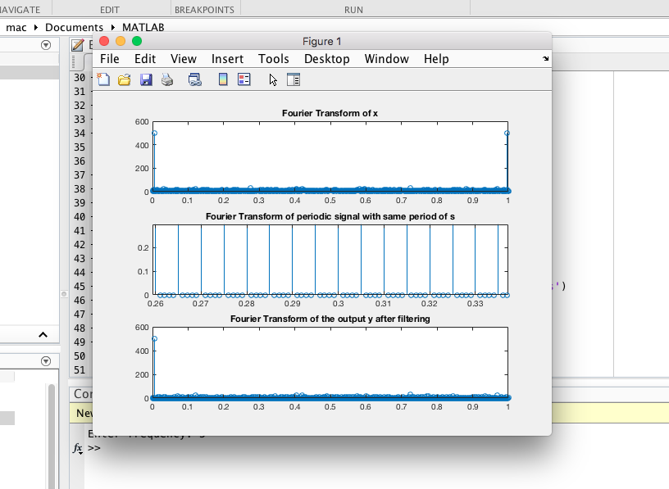

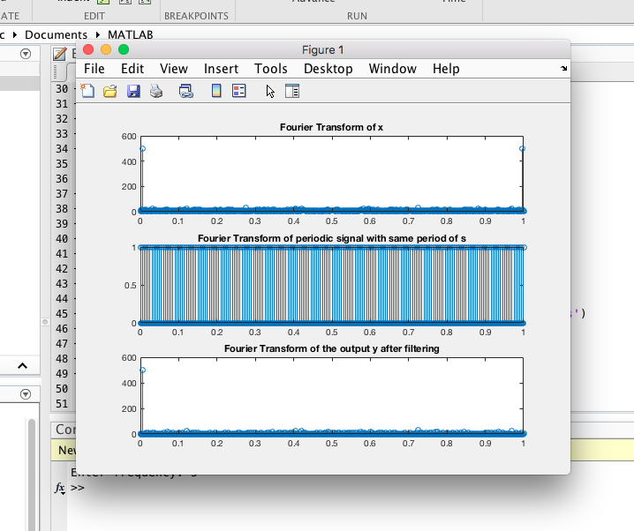

and then we calculated the inverse fourier of the output->

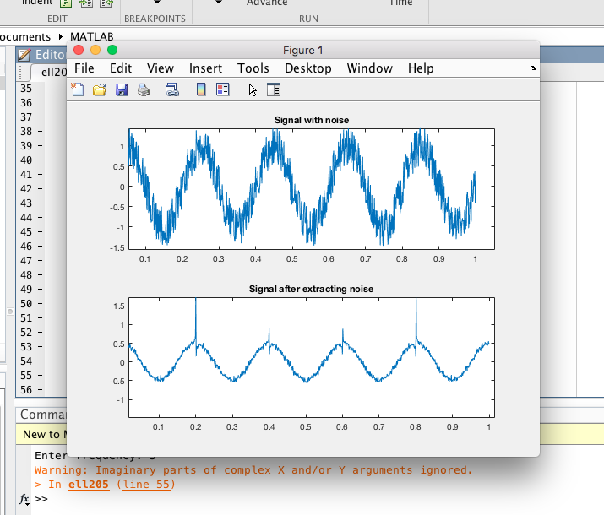

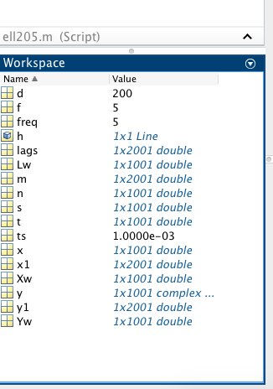

clear all;

close all;

clc;

f=input('Enter frequency: ');

ts=0.001;

t=0:ts:1;

s=sin(2*pi*f*t);

n=(rand(size(t))-0.5);

x=s+n;

subplot(2,1,1);

plot(t,x);

title('signal with noise');

% autocorrelation to get frequency of unknown signal x

[y,lags]=xcorr(x,x);

subplot(2,1,2);

plot(lags,y);

title('autocorrelation');

%computing the frequency

h=findobj(gca,'type','line');

y1=h.YData;

x1=h.XData;

d=find(x1==0);

m=movmean(y1,25);

while (m(d)>=m(d+1))

d=d+1;

end

while (m(d)<=m(d+1))

d=d+1;

end

d=d-1-1/ts;

freq=1/(d*ts);

freq;

%extracting the periodic part

Xw=abs(fft(x));

Lw=zeros(size(t));

Lw(1:round(freq):end)=1;

subplot(3,1,1);

stem(t,Xw);

title('Fourier Transform of x')

subplot(3,1,2);

stem(t,Lw);

title('Fourier Transform of periodic signal with same period of s')

Yw=Lw.*Xw;

subplot(3,1,3);

stem(t,Yw);

title('Fourier Transform of the output y after filtering')

y=(ifft(abs(Yw)));

subplot(2,1,1);

plot(t,x);

title('Signal with noise');

subplot(2,1,2);

plot(t,y);

title('Signal after extracting noise');

**References:**

* <https://www.youtube.com/watch?v=L8i5erRV7Bc&ab_channel=NagayalankaDurgarao>
* <https://www.tutorialspoint.com/detection-of-periodic-signals-in-the-presence-of-noise-by-autocorrelation>
* <https://www.tutorialspoint.com/detection-of-periodic-signals-in-the-presence-of-noise-by-cross-correlation#:~:text=Hence%2C%20if%20the%20cross%2Dcorrelation,of%20noise%20using%20cross%2Dcorrelation>.
* <https://www.youtube.com/watch?v=txmLrQ8OZuA&t=613s>
* <https://www.youtube.com/watch?v=uPblp3nM3Uc>
* <https://www.youtube.com/watch?v=CSBDW9DpkHI&t=1178s>